## Maven-Whole Practice Assignment

Create a first maven project, build a jar run the application locally & develop the environment add new dependencies to the project & run the tests.

Edit the POM file include the hibernate to perform transitive dependencies & then exclude that dependency.

Create a multi-layer project with maven & specify the dependency in that & Show the best practices to maintain the multi-module maven project.

Run some important commands useful while debugging the project & perform maven archetype plug-in to generate sample projects.

**Solution:**

1. Create a first maven project, build a jar run the application locally & develop the environment add new dependencies to the project & run the tests.

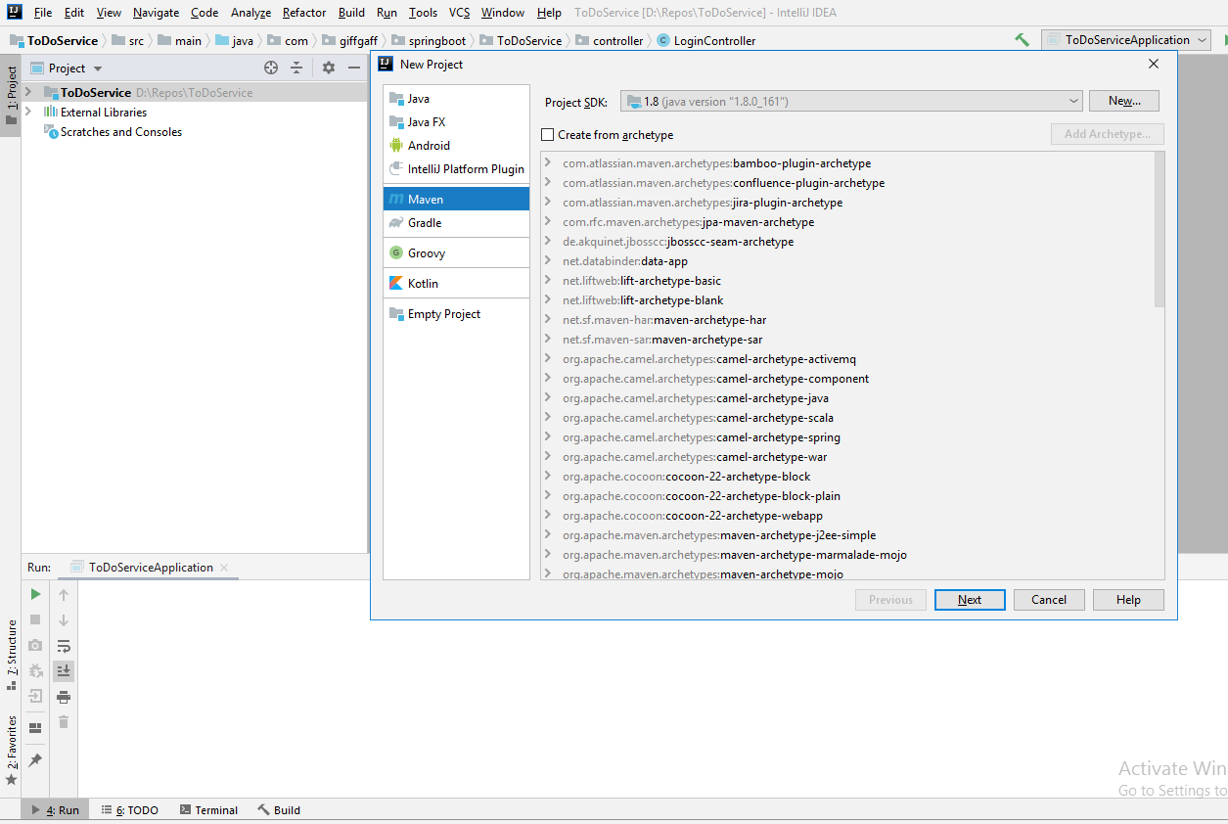

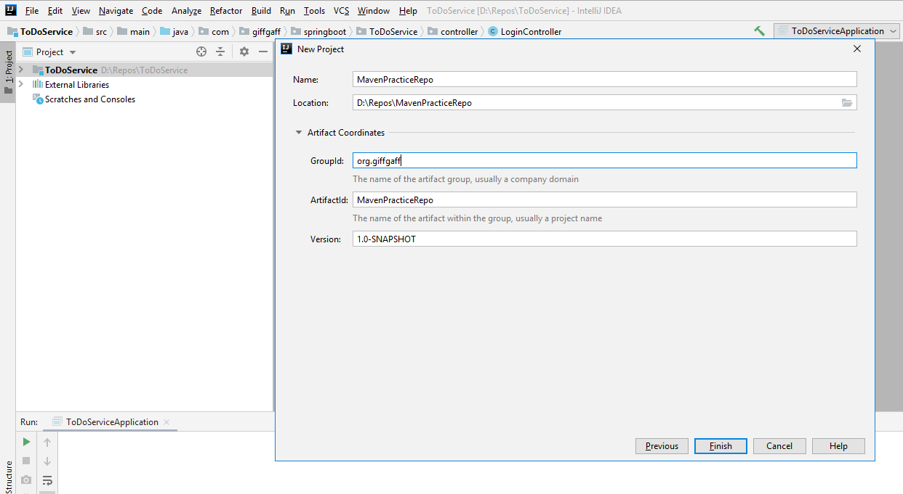

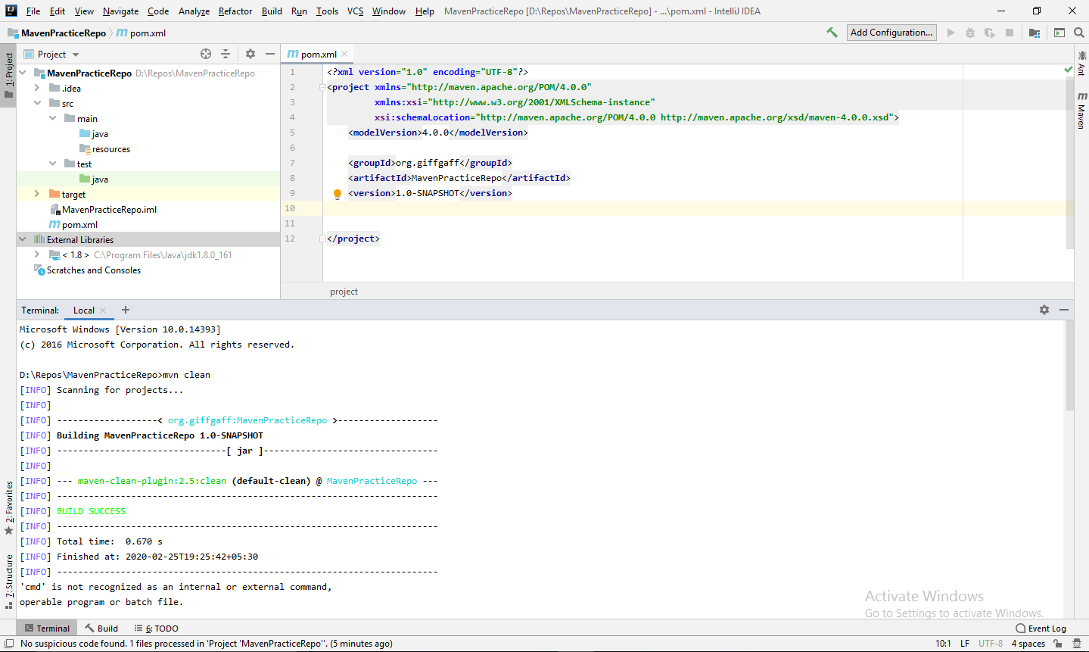

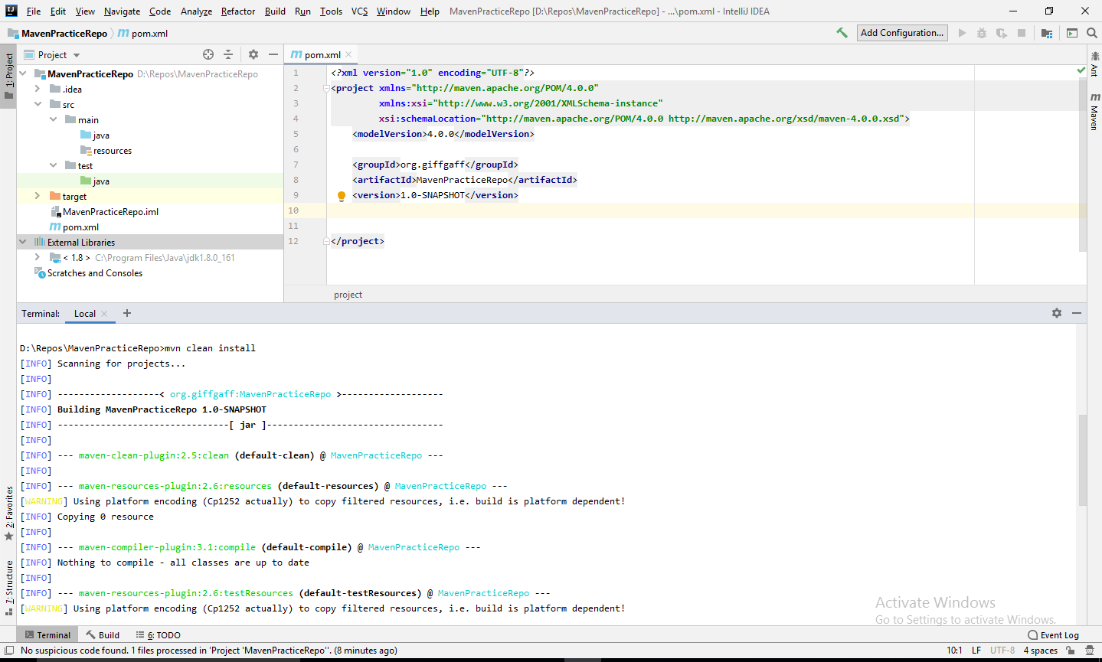

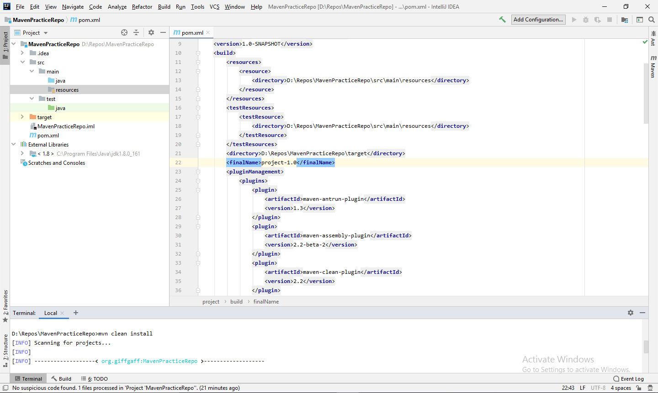

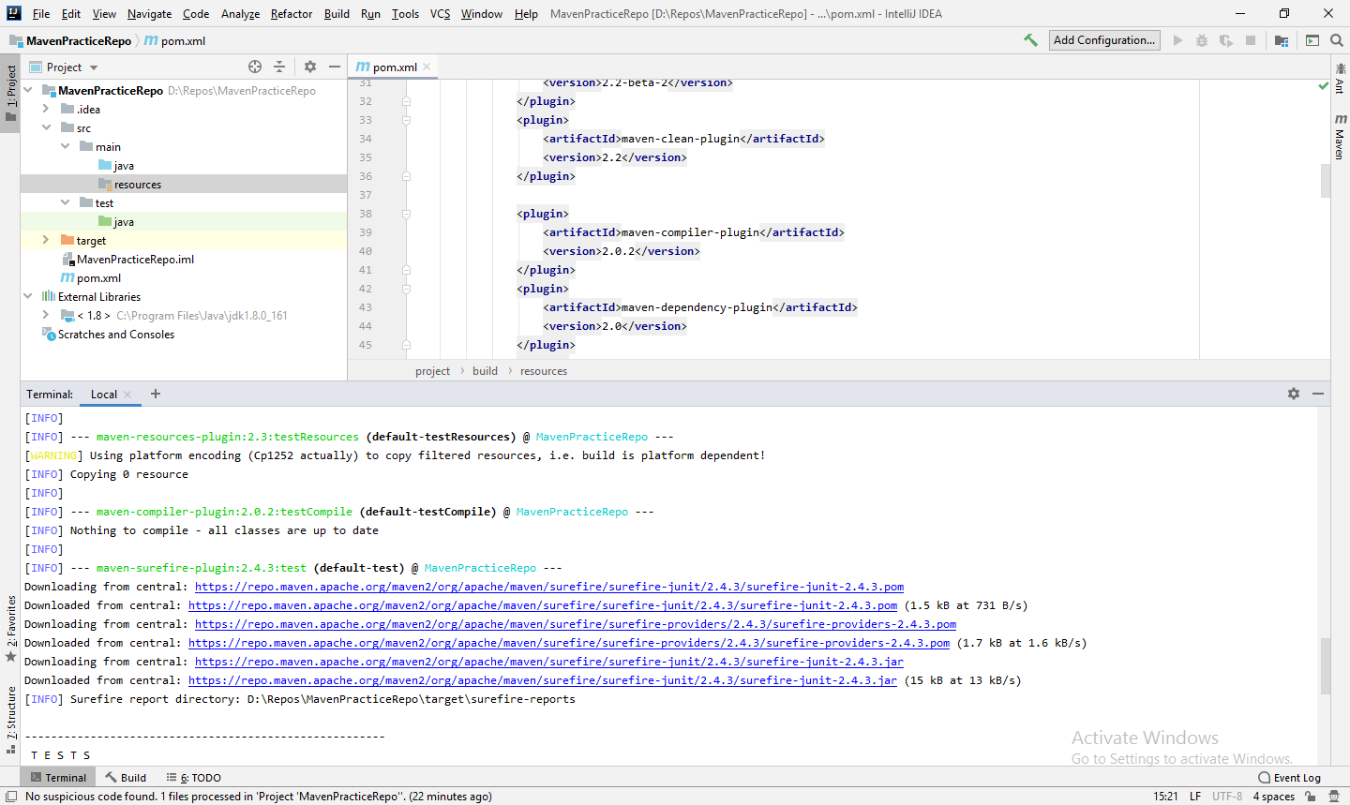

1. Edit the POM file include the hibernate to perform transitive dependencies & then exclude that dependency.

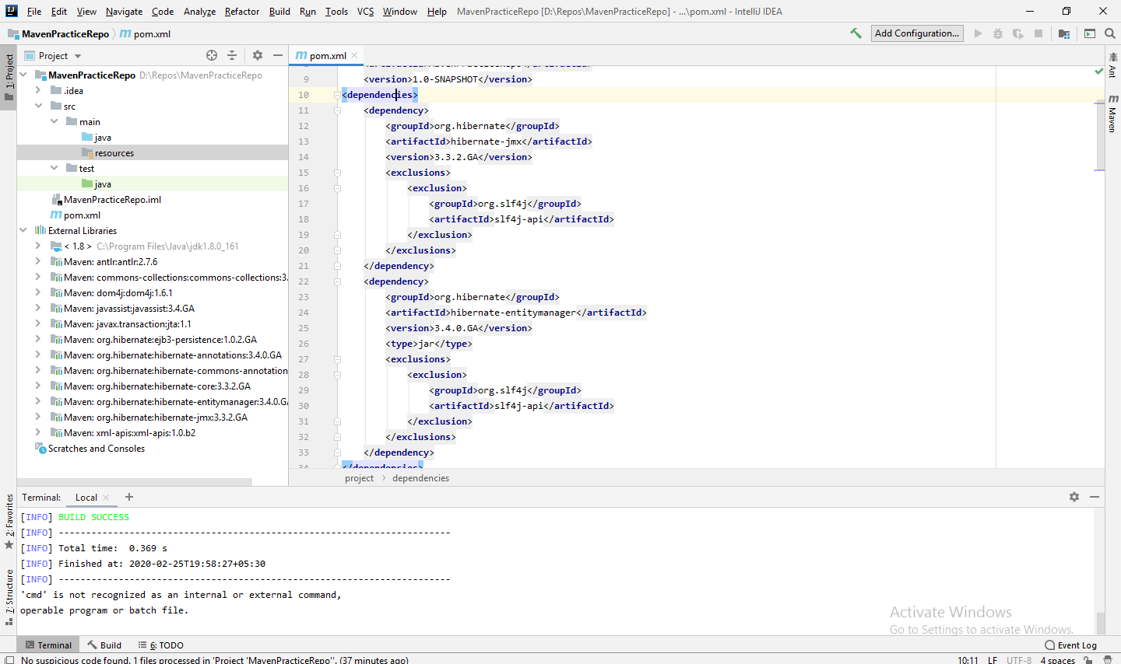

1. Create a multi-layer project with maven & specify the dependency in that & Show the best practices to maintain the multi-module maven project. Run some important commands useful while debugging the project & perform maven archetype plug-in to generate sample projects.
2. Creating Maven Project

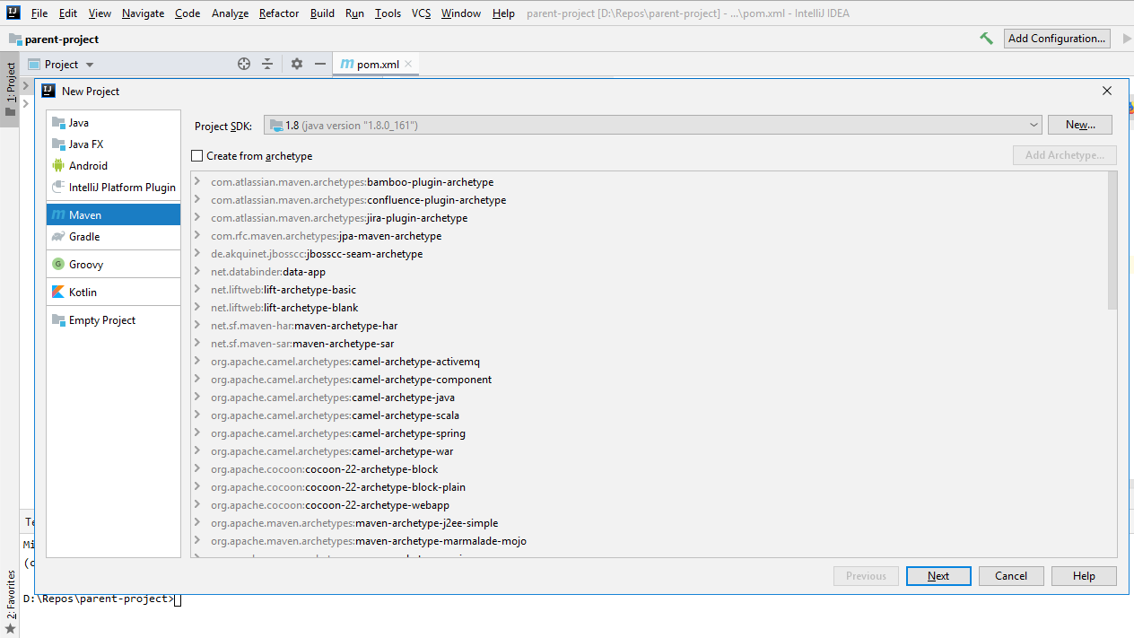

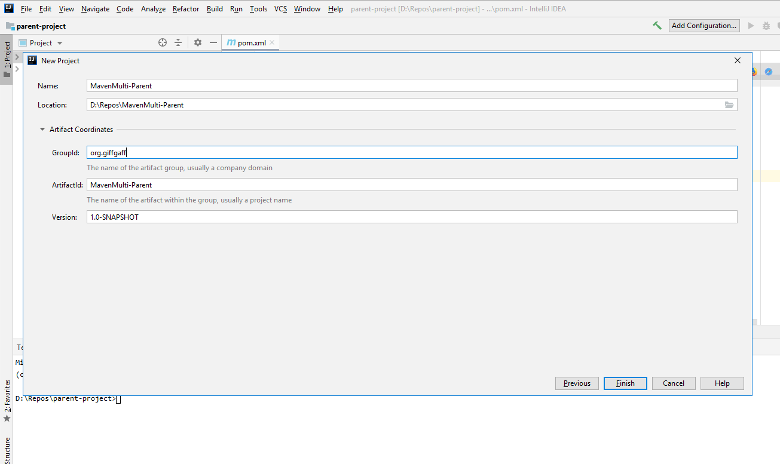

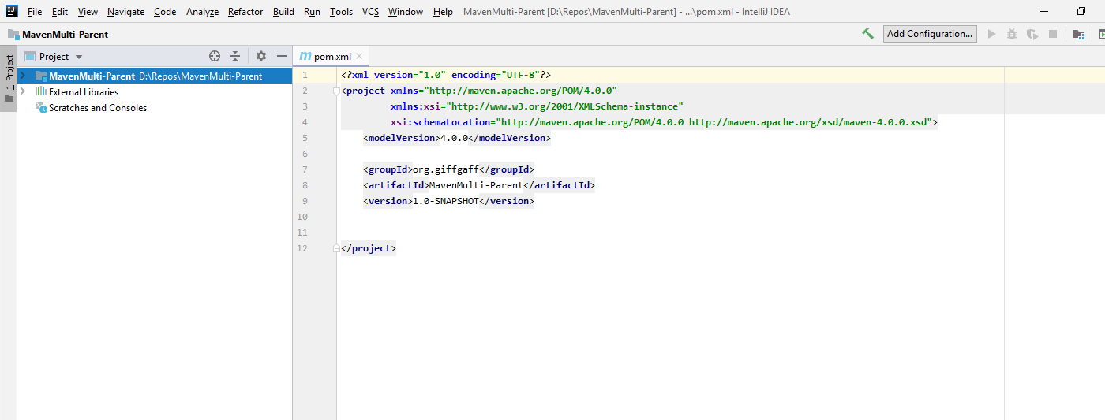

1. **Add packaging tag in the parent pom xml.**

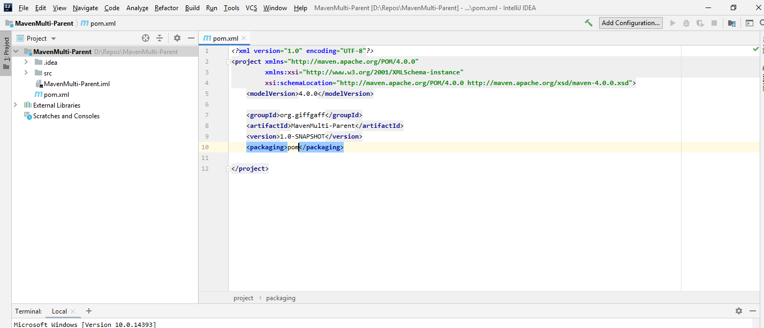

1. **Create a module from the parent maven project.**

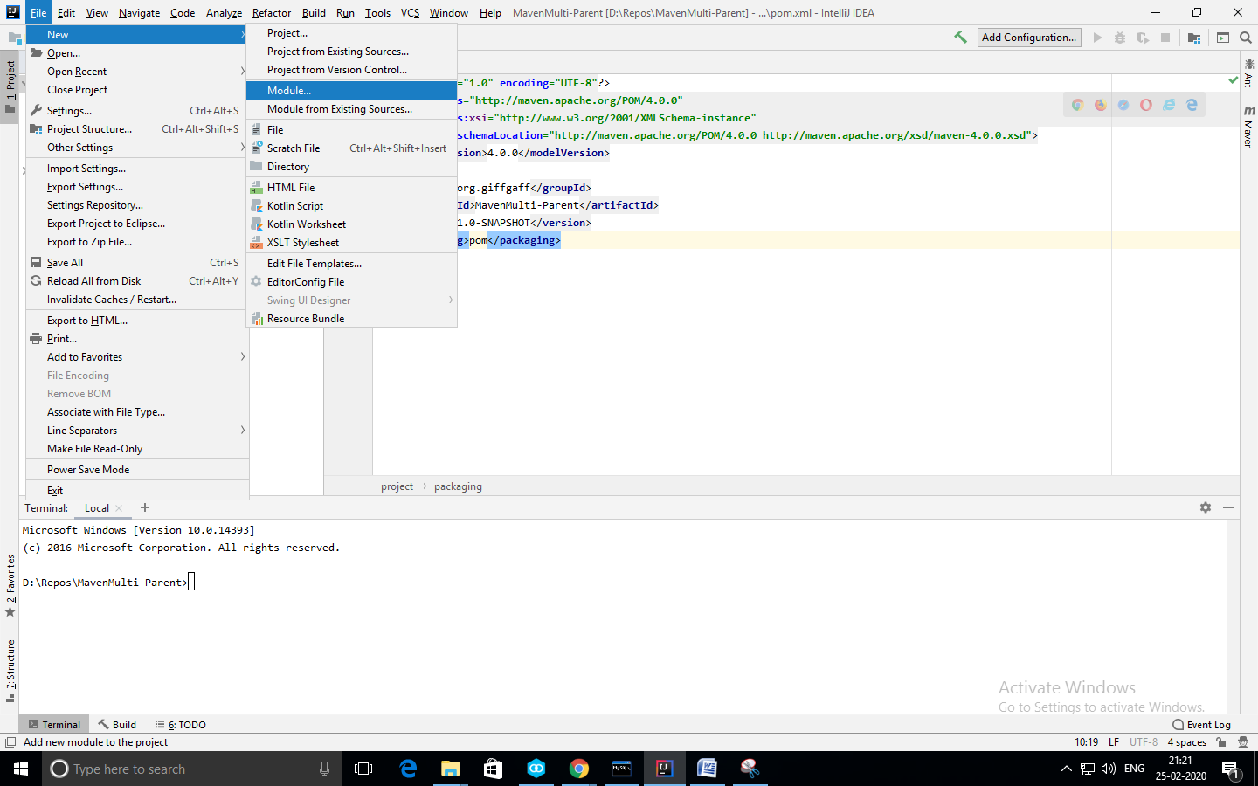

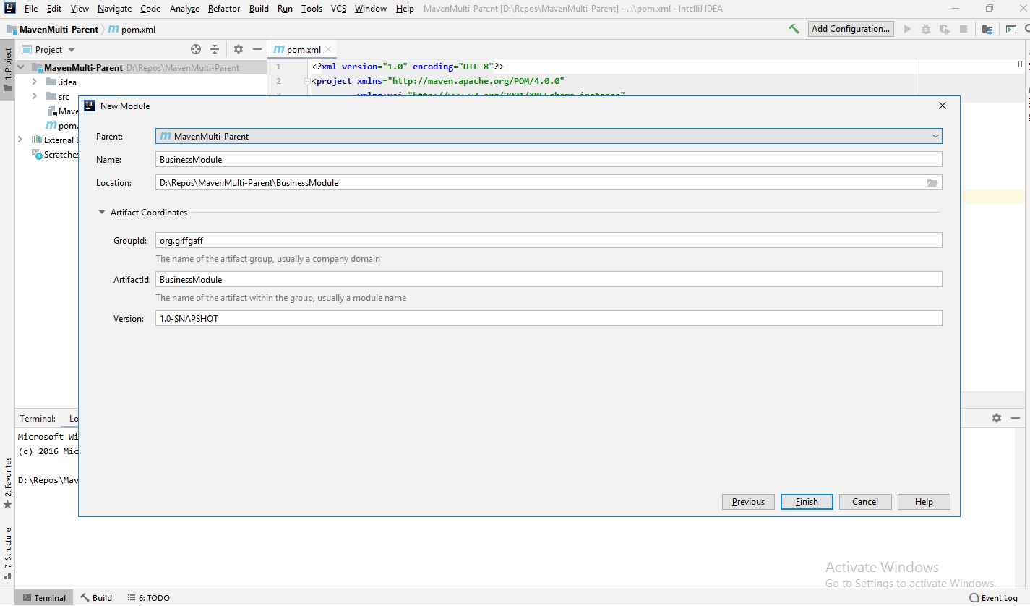

1. **We can see the both parent and child pom xml below**

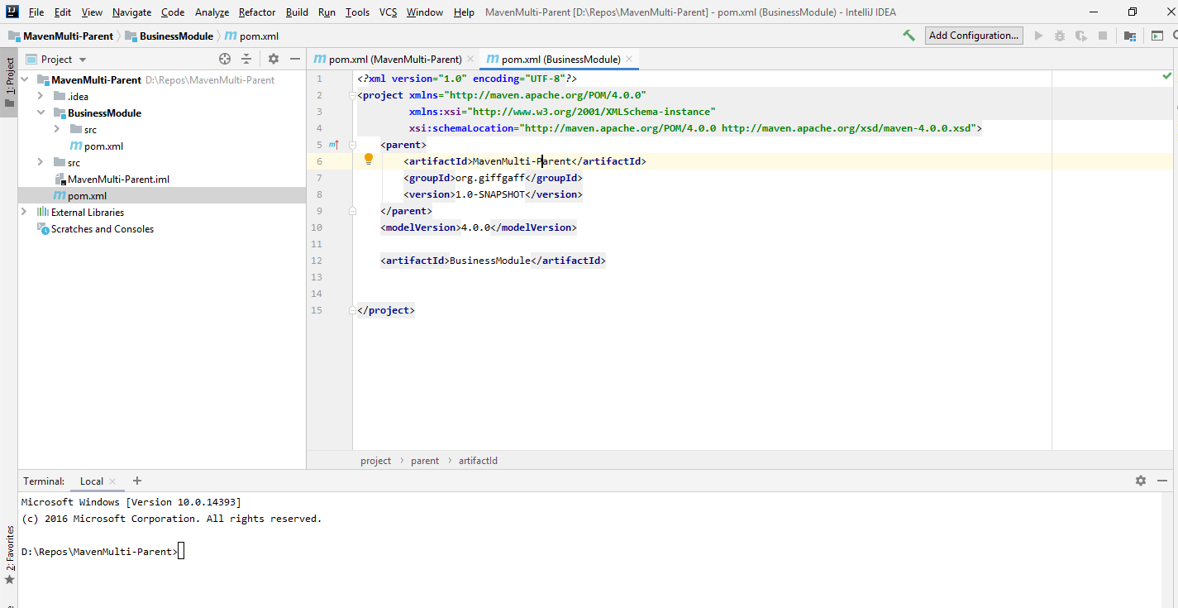

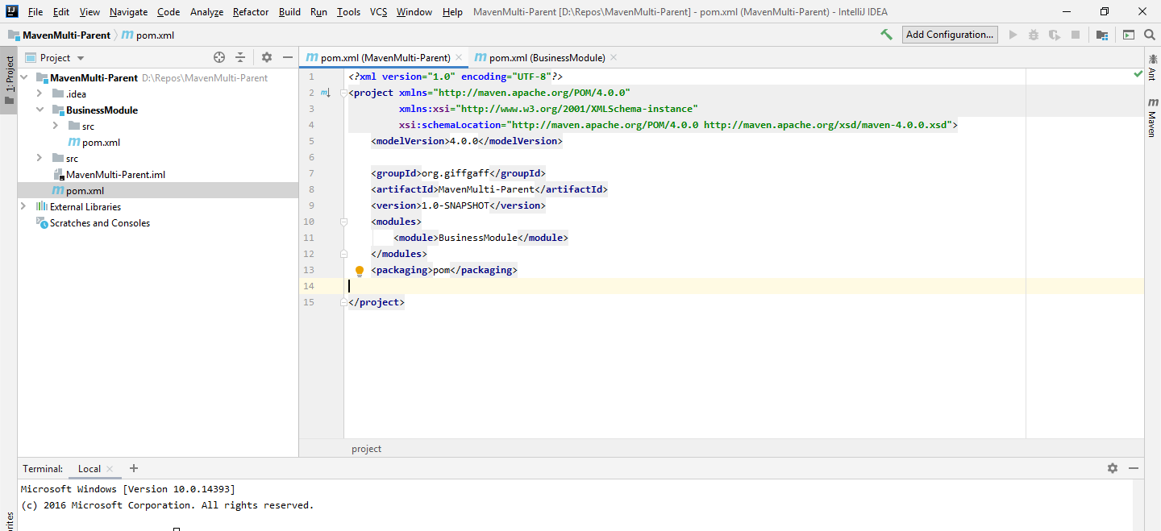

1. **Run the command “mvn clean” and now both parent and child module jars created.**

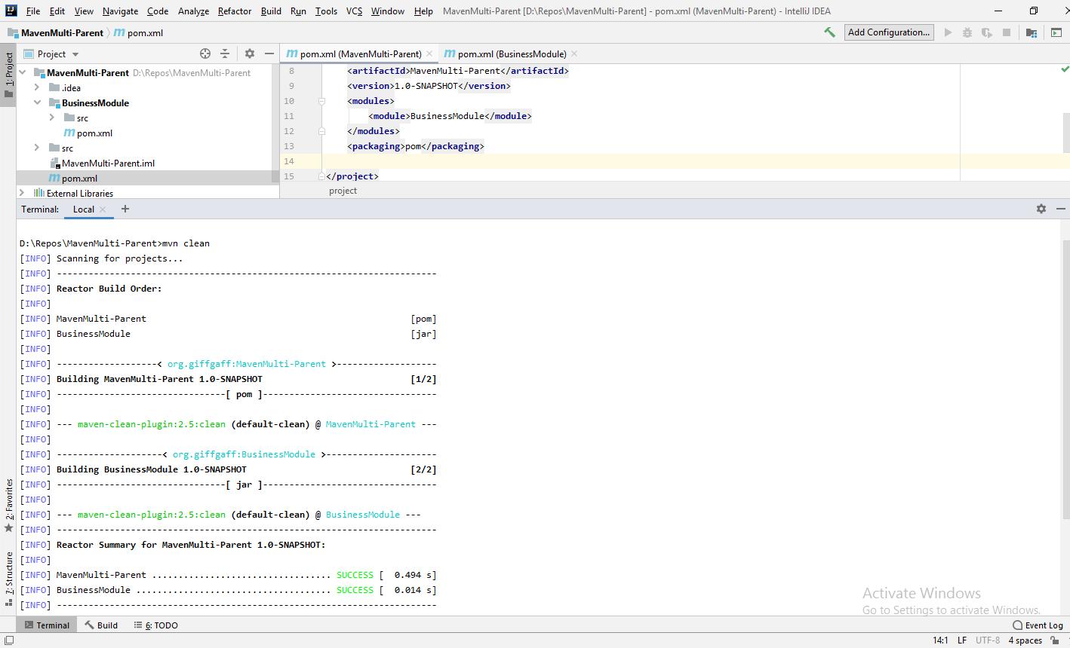

1. **Create another module called “DataModule”. Update the parent pom with one new module tag and update the references.**

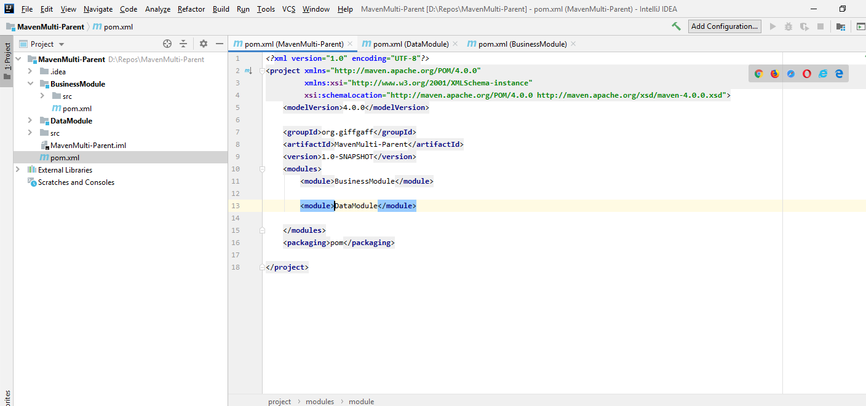

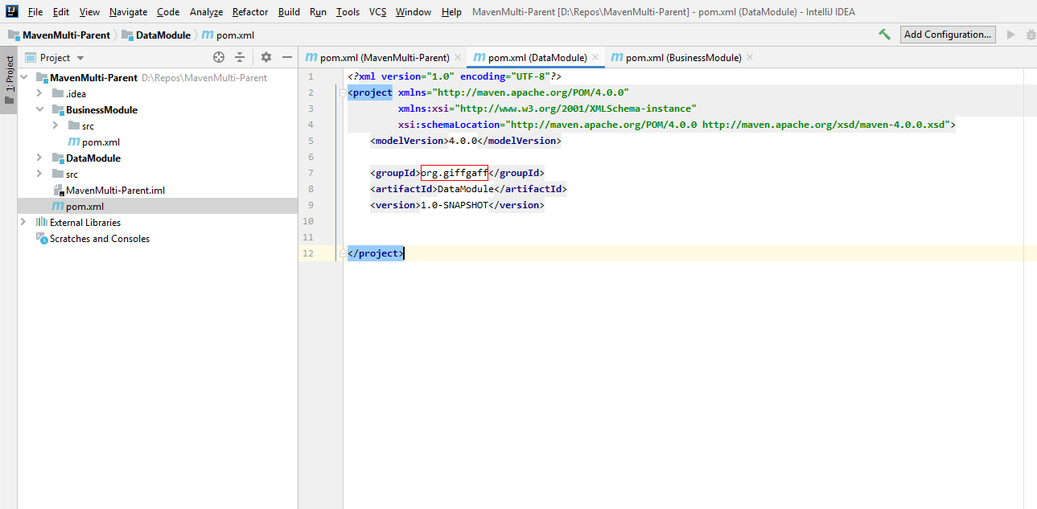

1. **Run the “mvn clean” / “mvn clean install” again to build the jars. Now 3 jars created.**

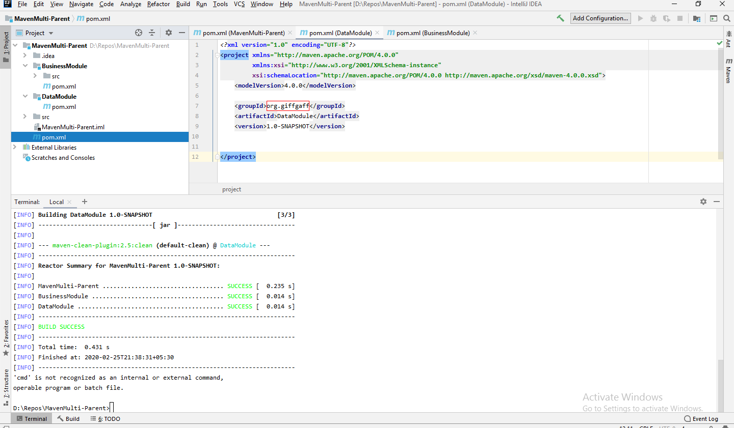

1. **Adding individual dependencies in the sub modules.**

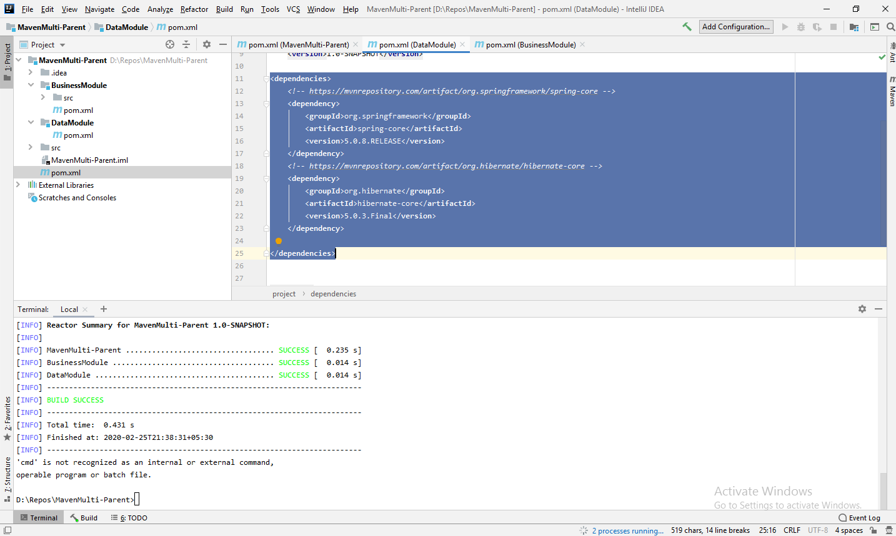

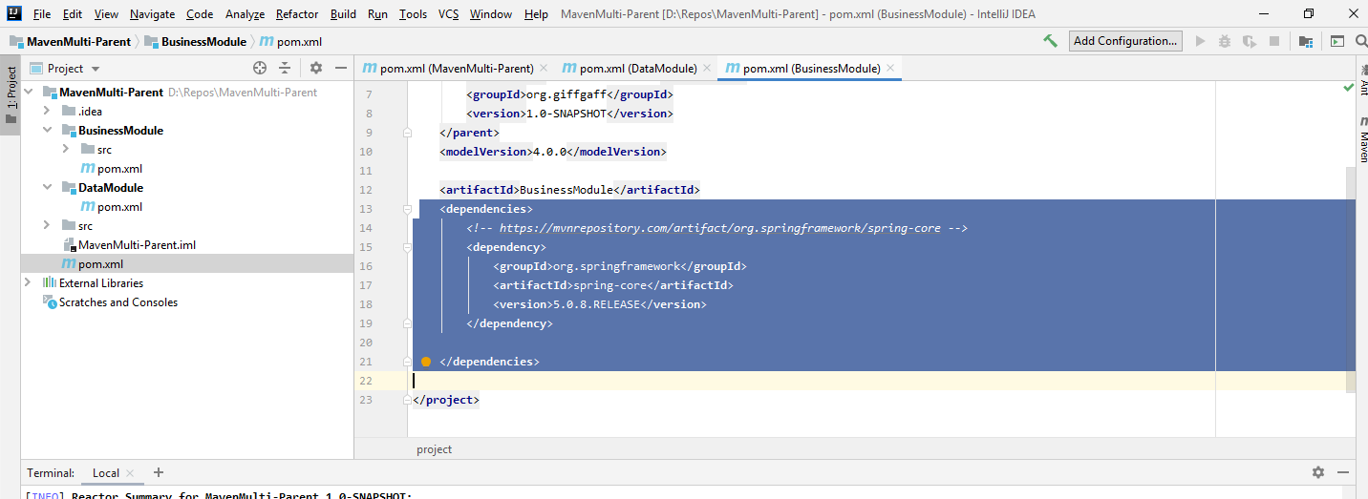

1. **Build the project from terminal “ mvn clean install”.**

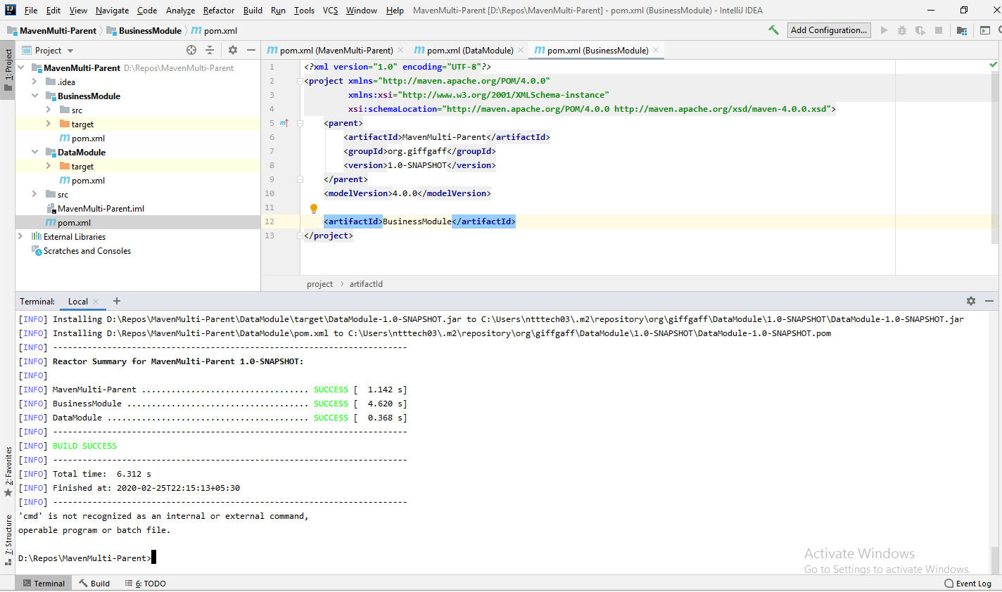

1. **Add Dependency management in parent xml.**

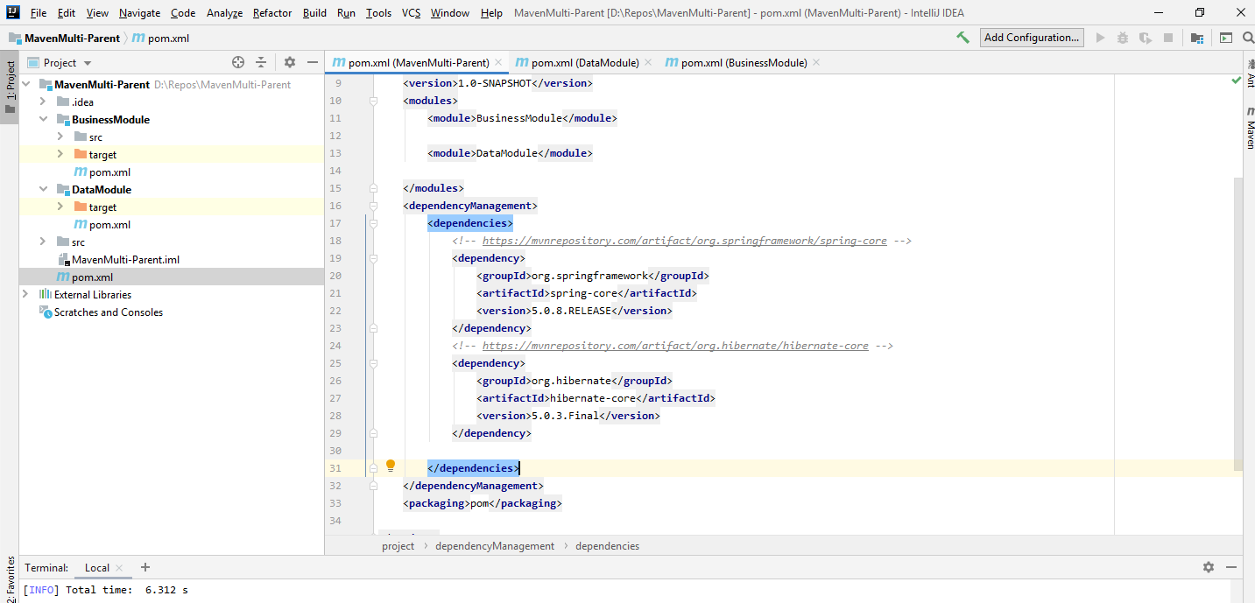

1. **Now remove the versions from the child module pom xml’s (maven best practices).**

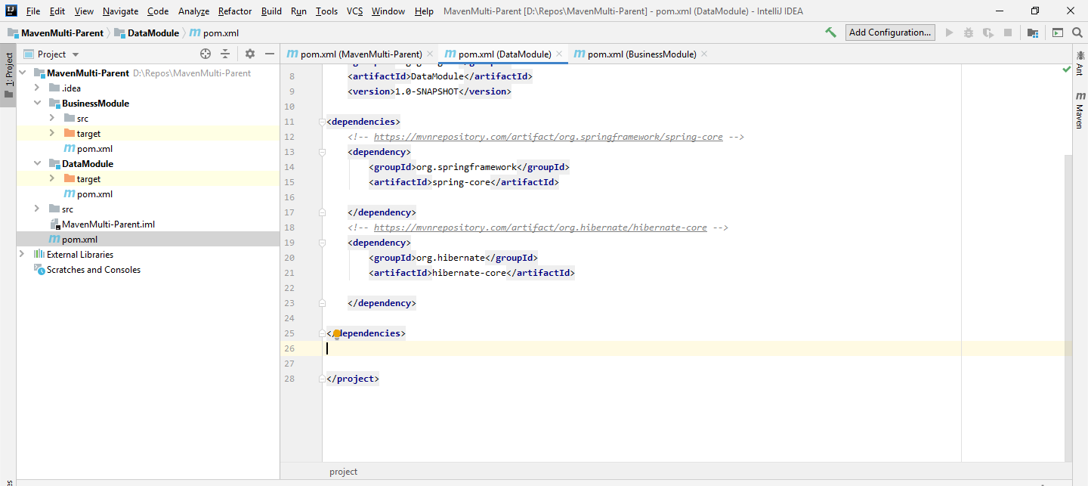

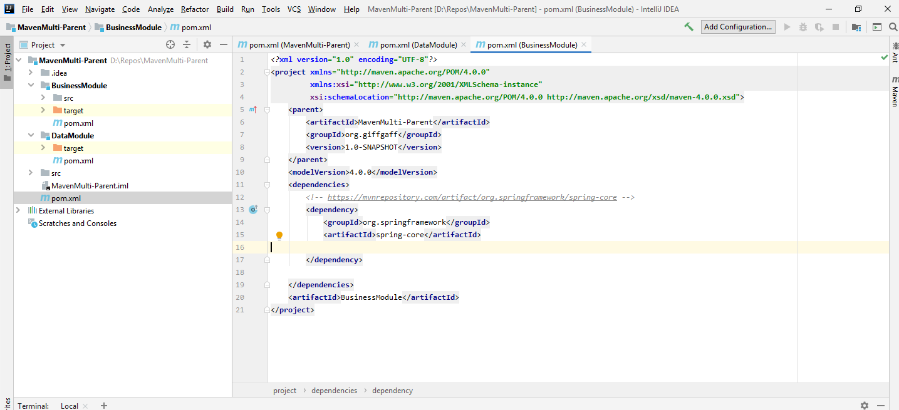

1. **Adding module dependency with artefact-id. Added data module dependency in business module pom.**

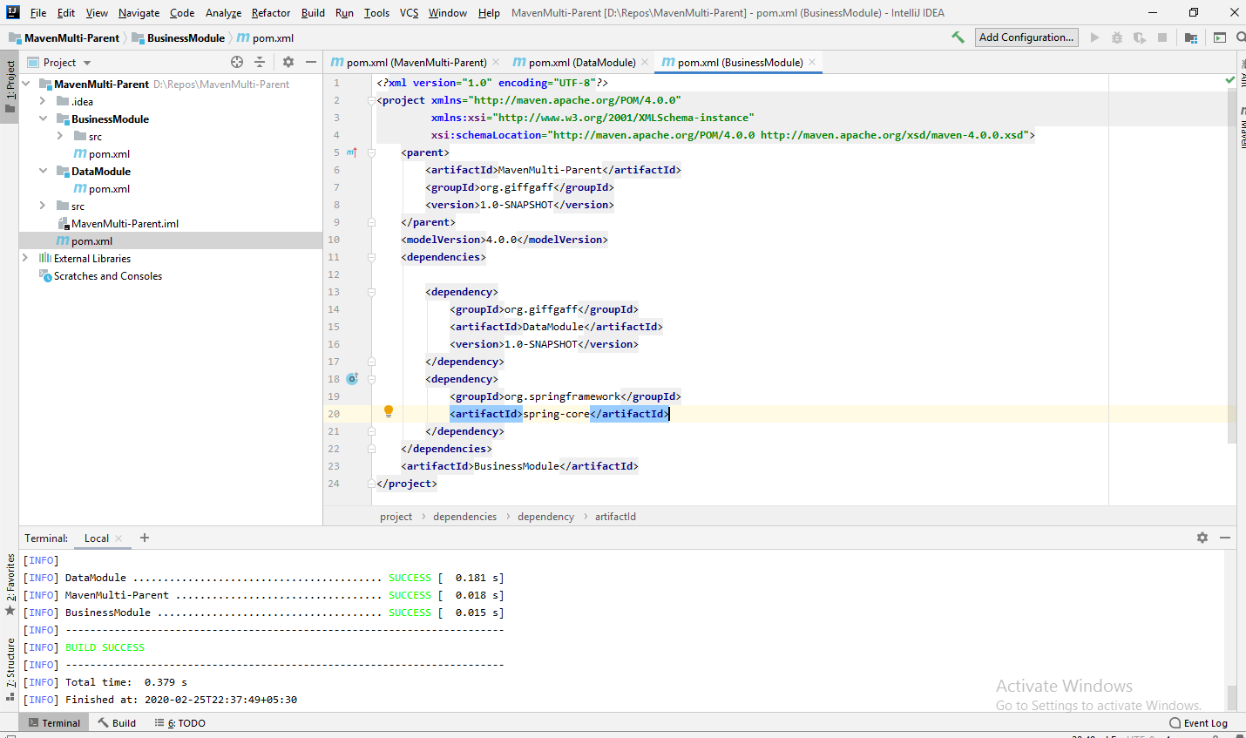

**Defining sub module version in pom:**

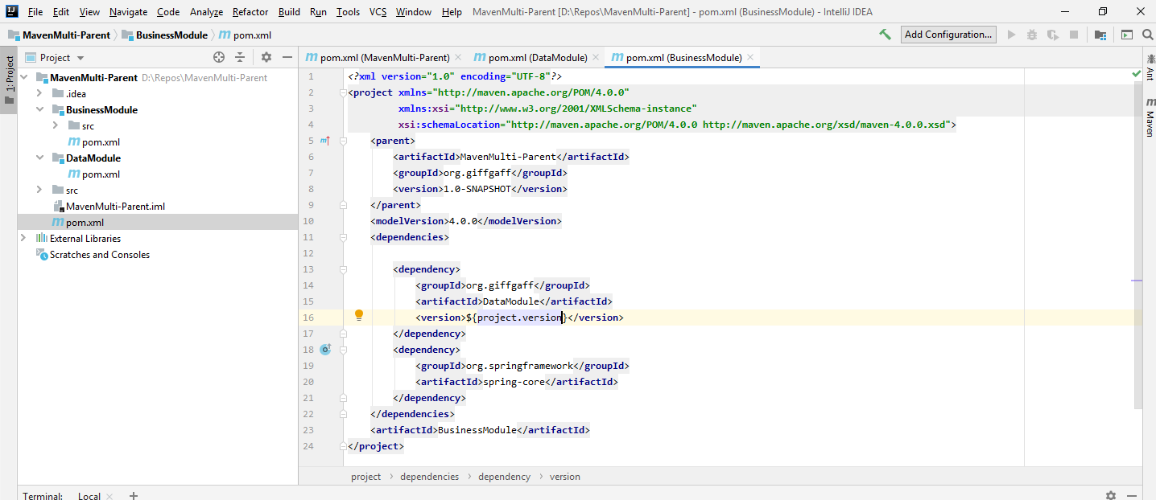

**Sub module dependency Adding to Parent pom and remove version from the child pom:**

